Project Report

1. Title Page

Project Title: Interactive Quiz Application

Submitted By:

Team Member: Tirth Patel, Amiya Prakash

Roll Number: 2460494, 2460325

College E-mail ID: [Tirth.manishbhai@btech.christuniversity.in](mailto:Tirth.manishbhai@btech.christuniversity.in), amiya.prakash@btech.christunversity.in

Course: UI/UX Design Fundamentals

Instructor Name: Nagaveena Mam

Institution: Christ University

Date of Submission: 26/09/2025

2. Abstract

This project is an interactive quiz application designed to allow users to answer multiple-choice questions, get immediate feedback, and track their score. The main goal is to create a dynamic, engaging, and responsive quiz experience for learners. Core technologies used include HTML5 for structure, CSS3 and Bootstrap for styling and responsive layout, and JavaScript/jQuery for interactivity, including question shuffling, timer functionality, and live score tracking. The final outcome is a fully functional quiz platform that can be used for learning, assessment, or entertainment, offering immediate feedback and score calculation with a user-friendly interface.

3. Objectives

* Create an interactive quiz with multiple-choice questions.
* Implement a timer for each question.
* Dynamically shuffle questions to ensure a unique order every time.
* Track user score and provide immediate feedback.
* Design a responsive interface suitable for desktop, tablet, and mobile devices.
* Utilize Bootstrap and CSS3 for styling and responsiveness.

4. Scope of the Project

* Front-end focused only; no server-side integration.
* Designed to handle 10 questions per quiz session.
* Shuffle questions for each attempt to enhance replay value.
* Shows immediate feedback and final score.
* Uses only open-source tools (HTML, CSS, JS, Bootstrap, jQuery).

5. Tools & Technologies Used

|  |
| --- |
| Tool/Technology Purpose |
| HTML5 Structure and markup |
| CSS3 Styling, responsive layout |
| Bootstrap Responsive grid and components |
| JavaScript Quiz logic, timer, feedback |
| jQuery DOM manipulation and event handling |
| VS Code Code editor |
| Chrome DevTools Testing and debugging |

6. HTML Structure Overview

* Used semantic tags: <header>, <main>, <section>, <footer>.
* Structured into sections: Quiz container, Options, Result container.
* Navigation for questions handled dynamically using jQuery.
* Buttons created with <button> tags and styled using Bootstrap classes.

7. CSS Styling Strategy

* External CSS file for main styling.
* Bootstrap used for grid, buttons, and responsive layout.
* Techniques used:
  + Flex box for button alignment and layout.
  + Progress bar animation using CSS transitions.
  + Hover effects for options.
  + Mobile-first design approach.
  + Color coding correct/incorrect answers dynamically.

8.Key Features

Feature Description

Question Shuffling Random order of questions on each attempt

Timer Functionality 15-second countdown for each question

Immediate Feedback Correct/incorrect answers shown instantly

Score Tracking Updates live and final score displayed at end

Responsive Design Works across desktop, tablet, and mobile

Progress Bar Animated bar showing quiz progression with color coding

9. Challenges Faced & Solutions

Challenge Solution

Dynamic question shuffling Used JavaScript shuffle function

Aligning option buttons Used Flex box and Bootstrap utility classes

Timer integration Used JavaScript set Interval with auto-next question

Displaying progress and score simultaneously Updated progress bar and score using jQuery

10. Outcome

* Fully functional interactive quiz app.
* Questions appear in a random order each time.
* Immediate feedback is provided and final score calculated accurately.
* Smooth and responsive layout across devices.
* Hands-on experience with HTML, CSS, Bootstrap, and jQuery integration.

11. Future Enhancements

* Add backend integration to store user scores.
* Add dynamic question database to allow infinite questions.
* Implement user authentication for personalized quizzes.
* Add animations and sounds for feedback.
* Include categories and difficulty levels for questions.

12. Sample Code

HTML (Quiz Container):

<div id="quiz-container">

<p id="question"></p>

<div id="options"></div>

<div class="d-flex justify-content-between">

<span class="timer">Time Left: <span id="time">15</span>s</span>

<button id="next-btn" class="btn btn-primary">Next</button>

</div>

</div>

<div id="result-container" style="display:none;">

<p class="result"></p>

<button id="restart-btn" class="btn btn-success">Restart Quiz</button>

</div>

JavaScript (Shuffling and Loading Questions):

function shuffle(array) {

for (let i = array.length - 1; i > 0; i--) {

const j = Math.floor(Math.random() * (i + 1));

[array[i], array[j]] = [array[j], array[i]];

}

return array;

}

function loadQuestion() {

const qData = quizData[currentQuestion];

$("#question").text(qData.question);

$("#options").empty();

qData.options.forEach((opt, i) => {

$("#options").append(

`<button class="btn btn-outline-primary option-btn" data-index="${i}">${opt}</button>`

);

});

}

13. Screenshots of Final Output

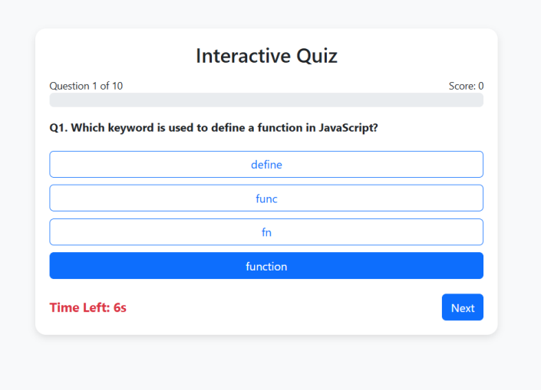 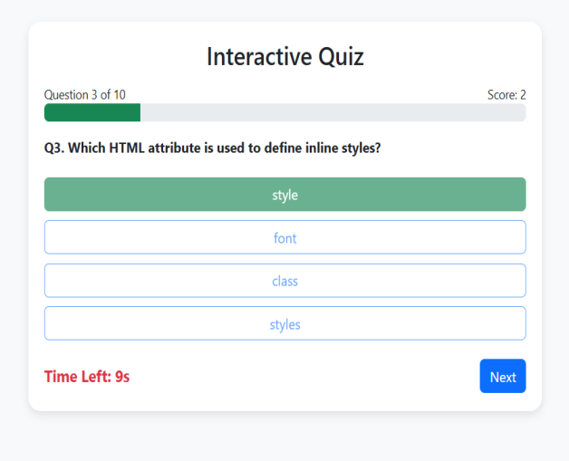

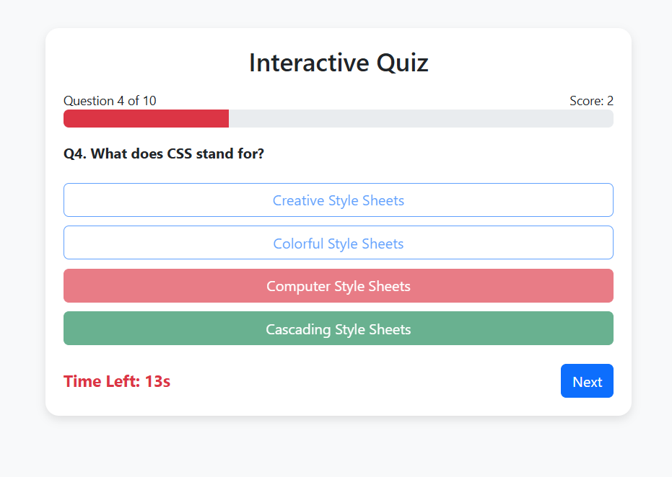 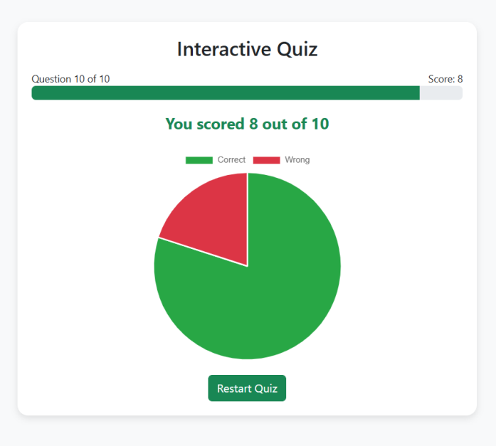

14. Conclusion

This Interactive Quiz App provides a dynamic, responsive, and engaging learning experience. It strengthened skills in DOM manipulation, responsive design, and interactive UI development. Implementing the timer, random question order, and live feedback enhanced practical knowledge of JavaScript and jQuery integration with HTML/CSS.

15. References

L&T LMS: https://learn.lntedutech.com/Landing/MyCourse